Hawaii is different than many other places where orchids are grown. Our climate changes drastically over a short period of space based on the elevation. Depending on what elevation you are at you can successfully grow different orchids.
To help, KOS developed a chart and color dot (on name tags) system corresponding to elevations and what orchids grow well at those given elevations.

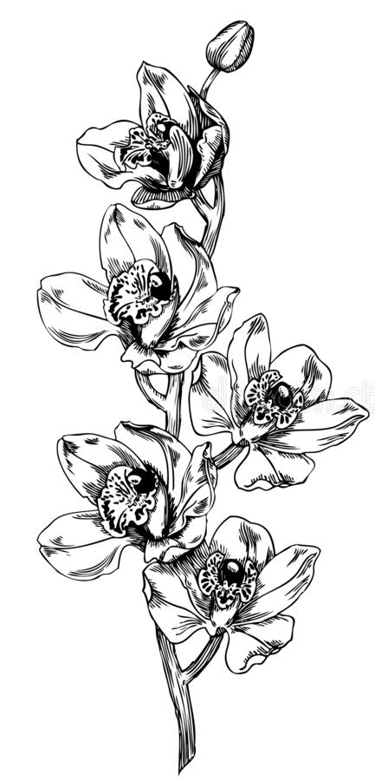
Red 0 feet to 500 feet
Brassavola
Cattleya
Grammatophyllum
Phalaenopsis
Warm growing Dendrobiums

Do not grow well: Cymbidiums, Miltonia, and Masdevallia

Yellow 500 feet to 1,000 feet
Brassavola
Bulbophyllum
Cattleya
Dendrobium
Oncidium
Phalaenopsis

Do not grow well: Cymbidiums, Miltonia, and Masdevallia

Green 1,000 feet to 1,500 feet
Brassavola
Bulbophyllum
Cattleya
Cymbidium
Dendrobium
Lycaste
Miltonia
Oncidium
Paphiopedilum
Phalaenopsis

Do not grow well: Masdevallia

Blue 1,500 feet and above
Miltonia
Oncidium
Cool growing Dendrobiums
Cool growing Cymbidiums

