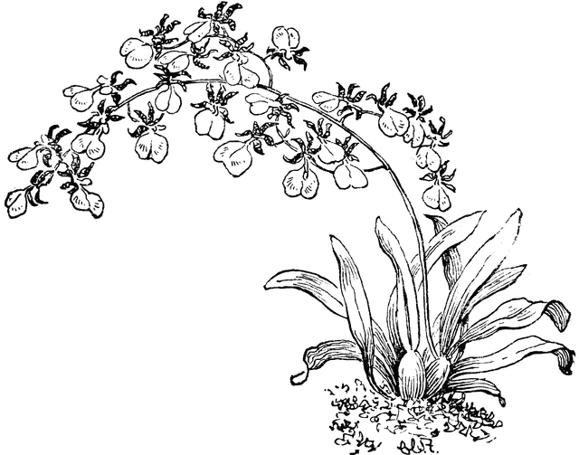
On-SID-ee-um
This is an extraordinarily large and diverse New World genus with an equally diverse number of habitats. Oncidiums may originate anywhere from sea level in the tropics to the high elevations of the Andes. This obviously makes cultural generalizations difficult. More specific instructions may be available from the grower. Some genera included are Aspasia, Brassia, warm- growing miltonias (often called the Brazilian type) and many of their hybrids.

Light needs can vary from bright to nearly full direct sun depending on the species. Most will thrive with one to several hours of sun a day. Generally, thicker leaved plants, such as "mule-ear" and "equitant" Oncidium tigrinum
oncidiums, can stand more light. In a greenhouse, 20 to 60 percent shade is required, or about 2,000 to 6,000 foot-candles, depending on the plants. In the home, east, south or west windows are ideal. Many types of oncidiums will grow under artificial light: Four fluorescent tubes supplemented with incandescent bulbs and placed 6 to 12 inches over the plants are necessary for proper growth. Metalhalide and sodium-vapor bulbs also provide sufficient light without needing to be so close to the plants.

Temperatures for this group are generally considered intermediate to warm: 55 to 60 F at night, and 80 to 85 F during the day. Temperatures up to 95 to 100 F are tolerated if humidity and air movement are increased as the temperatures rise, a good general rule in any case.

Water requirements vary with the type of plant. Generally, plants with large fleshy roots or leaves need less-frequent watering than thin-leaved or thin-rooted plants. Watering should be thorough, and the medium should dry at least halfway through the pot before watering again. This may be every two to 10 days depending on weather, pot size and material, type of orchid and type of potting medium. Plants not actively growing should be watered less; many species have winter rest periods.

Humidity Many oncidiums require less humidity than other orchids. Most greenhouses have adequate humidity. In the home, placing the plants above moist pebbles in trays is ideal.

Fertilize regularly while plants are actively growing. Applications of 30-10-10 formulations twice a month are ideal for plants in a bark-based potting medium. A 20-20-20 formulation should be used on plants in other media or on slabs. If skies are cloudy, applications once a month are sufficient.

Potting should be done when new growth is about one-half mature, which is usually in the spring. Fine-grade potting media are usually used with fine-rooted plants and coarser mixes with large-rooted plants; the standard size is medium grade. The plant should be positioned in the pot so that the newest growth is farthest away from the edge of the pot, allowing the maximum number of new growths before crowding the pot. Spread the roots over a cone of potting medium and fill in around the roots. Firm the medium around the roots. Keep humidity high and the potting medium dry until new roots form. Equitant and mule-ear oncidiums, as well as other fleshy-leaved or large-rooted plants, can be grown on slabs of cork bark or tree fern or in pots filled with a coarse, well-drained medium such as charcoal. This allows the drying between waterings that these types need.

