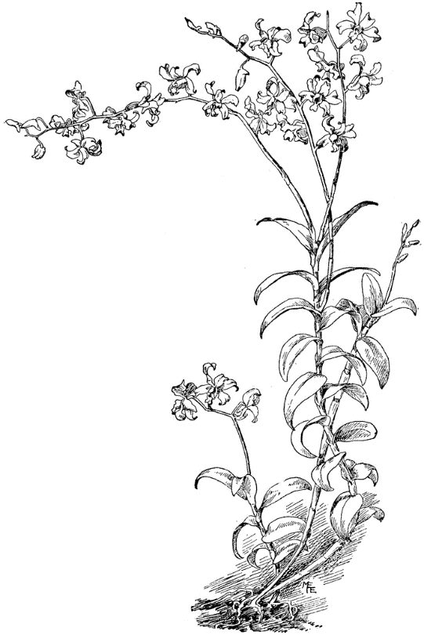
den-DROH-bee-um
Dendrobium is a diverse genus of orchids with different cultural needs. Many go through a growth phase and then a rest phase during the course of one year, and must be given water and temperature to match these periods of growth and rest. Flowers can last one day to many weeks, depending on the type. Owing to the extreme diversity of the genus, we have categorized culture according to the following main types:

PHALAENANTHE Evergreen for several years, with thin, tall pseudobulbs, terminal inflorescences, usually appearing in the autumn or twice a year (see culture). Species such as Den. affine, Den. bigibbum (phalaenopsis), Den. dicuphum and Den. williamsianum.

Culture Grow warm year-round (see below); 60 F nights; water and fertilize heavily when roots appear from new growth; medium light; reduce water and fertilizer after growth finishes. If a short (three- to four-week), cooler (55 F) dry rest is given, and then plants are warmed again (60 F mininum), another growth may mature during winter and flower in the spring. Treat this growth as a summer growth cycle. These grow well with phalaenopsis, except for the rest period. Plants will go deciduous if grown too cool and dry. Dendrobium superbiens

SPATULATA (Antelope Type) Evergreen for several years. Most are large, vigorous plants with long-lasting flowers in summer to several times a year. Species such as Den. antennatum, Den. canaliculatum, Den. discolor, Den. gouldii, Den. johannis, Den. lineale (veratrifolium), Den. stratiotes, Den. strebloceras and Den. taurinum.

Culture Warm all year (60 to 65 F nights, 75 to 90 F days); no rest period; can be kept cooler in winter if dry; medium to high light.

DENDROBIUM Most of the plants are pendulous, with leaves all along the canes that most often drop with onset of cooler, drier weather. One to five flowers per node are borne from the nodes of the leafless canes in midwinter through early spring.

Group 1 Species such as Den. chrysanthum, Den. friedricksianum, Den. nobile and Den. wardianum

Culture Growth period in summer; give warmth, water and fertilize heavily from when roots appear until top leaf appears on canes. Then give high light, little or no water, no fertilizer, cool nights (40 to 50 F). In other words, forget about them.

Group 2 Species such as Den. anosmum (superbum), Den. crassinode, Den. falconeri, Den. fimbriatum, Den. findlayanum, Den. heterocarpum (aureum), Den. loddigesii, Den. moniliforme, Den. parishii, Den. primulinus and Den. transparens.

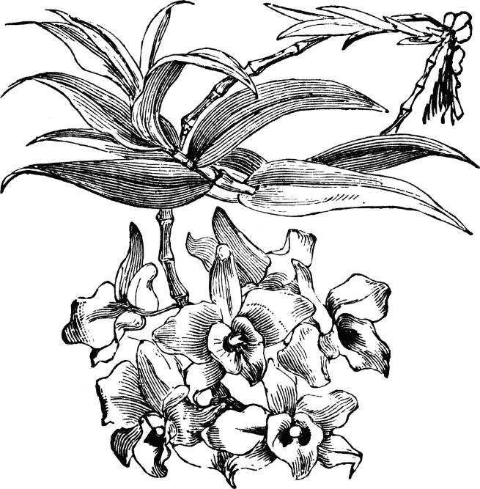
Culture Same as Group 1, but winter nights 55 F. Deciduous species need virtually no water in winter.

CALLISTA Most are pseudobulbous plants with pendent inflorescences. Species such as Den. aggregatum (now properly lindleyi), Den. chrysotoxum, Den. densiflorum, Den. farmeri and Den. thyrsiflorum.

Culture Summer give warmth (60 to 90 F), medium light, medium quantities of water and fertilizer. Winter keep cool (50 F nights), medium light, just enough water to keep pseudobulbs from shriveling, no fertilizer.

LATOURIA Leaves at top of pseudobulbs are large and leathery, inflorescence erect, flowers commonly yellow-green. Species such as Den. atroviolaceum, Den. macrophyllum and Den. spectabile.

Culture Same as antelope types, but cooler and drier when resting in winter. Dendrobium nobile

FORMOSAE (Nigrohirsutae Type) Canelike pseudobulbs, with black hairs on leaf sheaths and pseudobulbs often apparent, leading to the popular name nigrohirsutae. Flowers usually white, Photo Credit: Nadeza Kokorina
up to 4 inches across, two to three together from near the end of
the pseudobulb. Long lasting. Species such as Den. bellatulum, Den.
dearii, Den. draconis, Den. formosum, Den. infundibulum, Den. lowii,
Den. lyonii, Den. margaritaceum, Den. sanderae and Den. schuetzii.

Culture Intermediate to cool year round, 50 to 60 F nights, maximum 85 F days. Water and fertilize when growing; give a slight short rest (dry) when growth is completed. Keep barely moist until growth starts again.

OTHER SPECIES Among the popular types are Den. linguiforme, Den. tetragonum, Den. gracillimum and Den. cuthbertsonii (sophronitis).

Culture Depends on the plant's native environment. It is generally safe to grow them intermediate to warm (55 to 60 F at night), drying them out in winter (or as growth stops). Hybrids between sections vary in culture.

