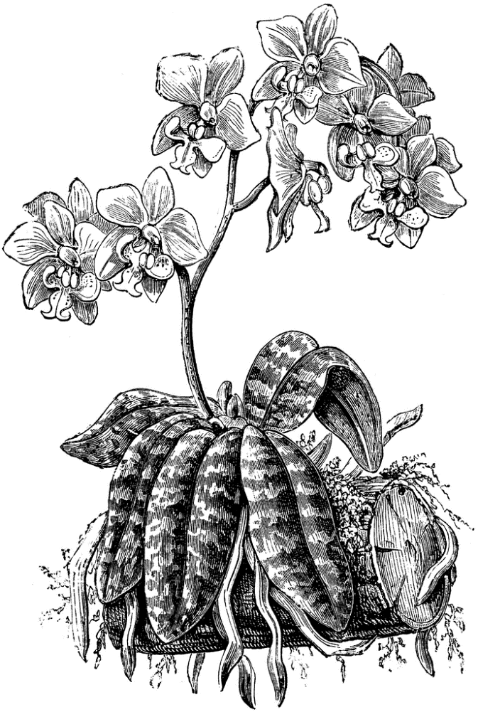
fayl-eh-NOP-siss
Phalaenopsis, the moth orchid, is perhaps the best orchid for growing in the home, and is also a favorite with greenhouse growers. Well-grown plants can flower often, sometimes with a few flowers throughout the year, though the main season is late winter into spring. Average home temperatures and conditions are usually sufficient. Flower stems on certain hybrids can be forced to rebloom by cutting the tip off after the initial flowering. Only healthy plants should be induced to flower repeatedly. Culture for Doritis, a related genus, thought by some to be conspecific with Phalaenopsis, and Doritaenopsis, a hybrid between the two genera, is the same as for pure Phalaenopsis.

Light is easy to provide for phalaenopsis. They grow easily in a bright window, with little or no sun. An east window is ideal in the home; shaded south or west windows are acceptable. In a greenhouse, shade must be given; 70 to 85 percent shade, or between 1,000 and 1,500 foot-candles, is recommended. No shadow should be seen if you hold your hand one foot above a plant's leaves.

Temperatures for phalaenopsis should usually be above 60 F at night, and range between 75 and 85 F or more during the day. Although higher temperatures force faster vegetative growth, higher humidity and air movement must accompany Phalaenopsis schilleriana higher temperatures, the recommended maximum being 90 to 95 F. Night temperatures to 55 F are desirable for several weeks in the autumn to initiate flower spikes. Fluctuating temperatures can cause bud drop on plants with buds ready to open.

Water is especially critical for phalaenopsis. Because they have no major water-storage organs other than their leaves, they must never completely dry out. Plants should be thoroughly watered and not watered again until nearly dry. In the heat of summer in a dry climate, this may be every other day; in the winter in a cool northern greenhouse, it may be every 10 days. Water only in the morning, so that the leaves dry by nightfall, to prevent rot.

Humidity is important to phalaenopsis, the recommended humidity being between 50 and 80 percent. In humid climates, as in greenhouses, it is imperative that the humid air is moving. Leaves should be dry as soon as possible, always by nightfall. In the home, set the plants on trays of gravel, partially filled with water, so that the pots never sit in water.

Fertilize on a regular schedule, especially if the weather is warm, when the plants are most often growing. Twice-a-month applications of high-nitrogen fertilizer (such as 30-10-10) are appropriate where bark-based media are used. Otherwise, a balanced fertilizer is best. When flowering is desired, a high-phosphorus fertilizer (such as 10-30-20) can be applied to promote blooming. Some growers apply fertilizer at one-quarter strength with every watering; this is best for warm, humid conditions. When cooler, or under overcast conditions, fertilizer should be applied twice per month at weak strength.

